# Client Side Scripting

## URLs

|  |  |
| --- | --- |
| GitHub Repository | <https://github.com/mandyfarrugia/mf_swd62b_css> |
| Remote Website | <https://mf-swd62b-css.onrender.com/> |

## Screenshots

### KU2.3 - Running the provided backend

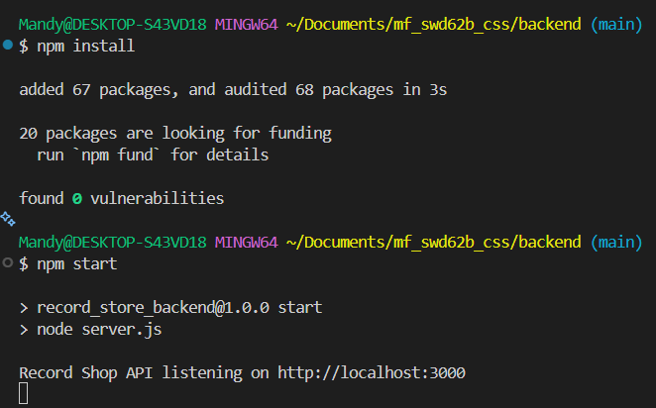

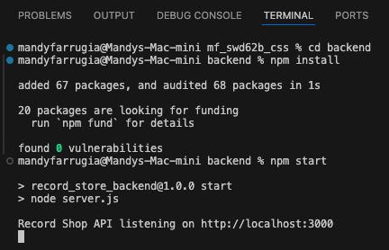

### KU2.3 - Accessing the API’s documentation in the browser

#### Health Check

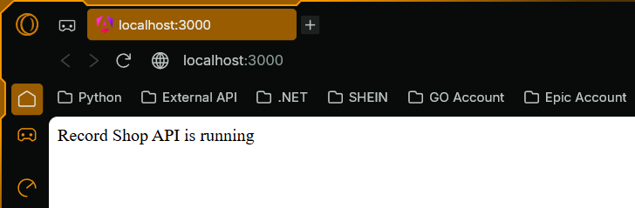

#### Records

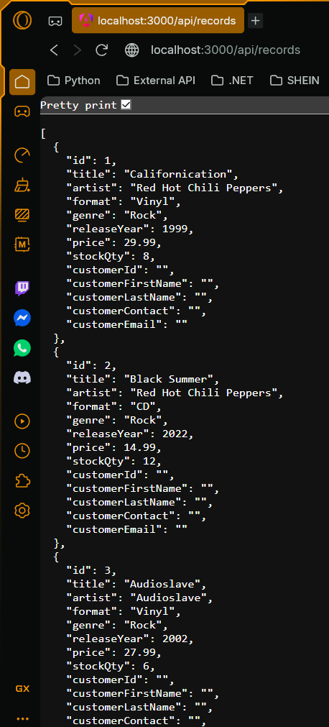

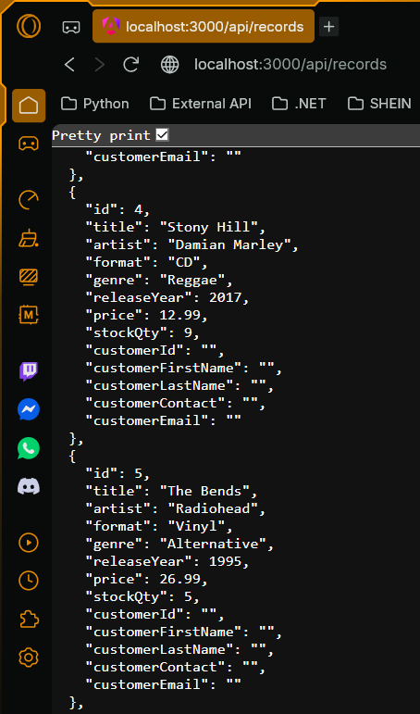

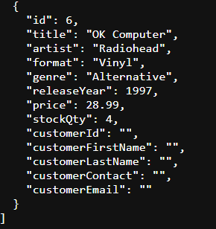

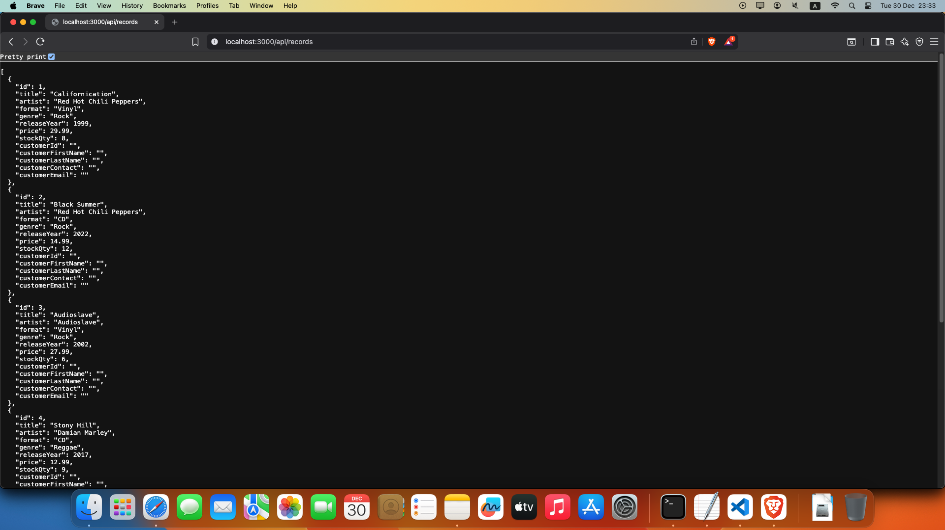

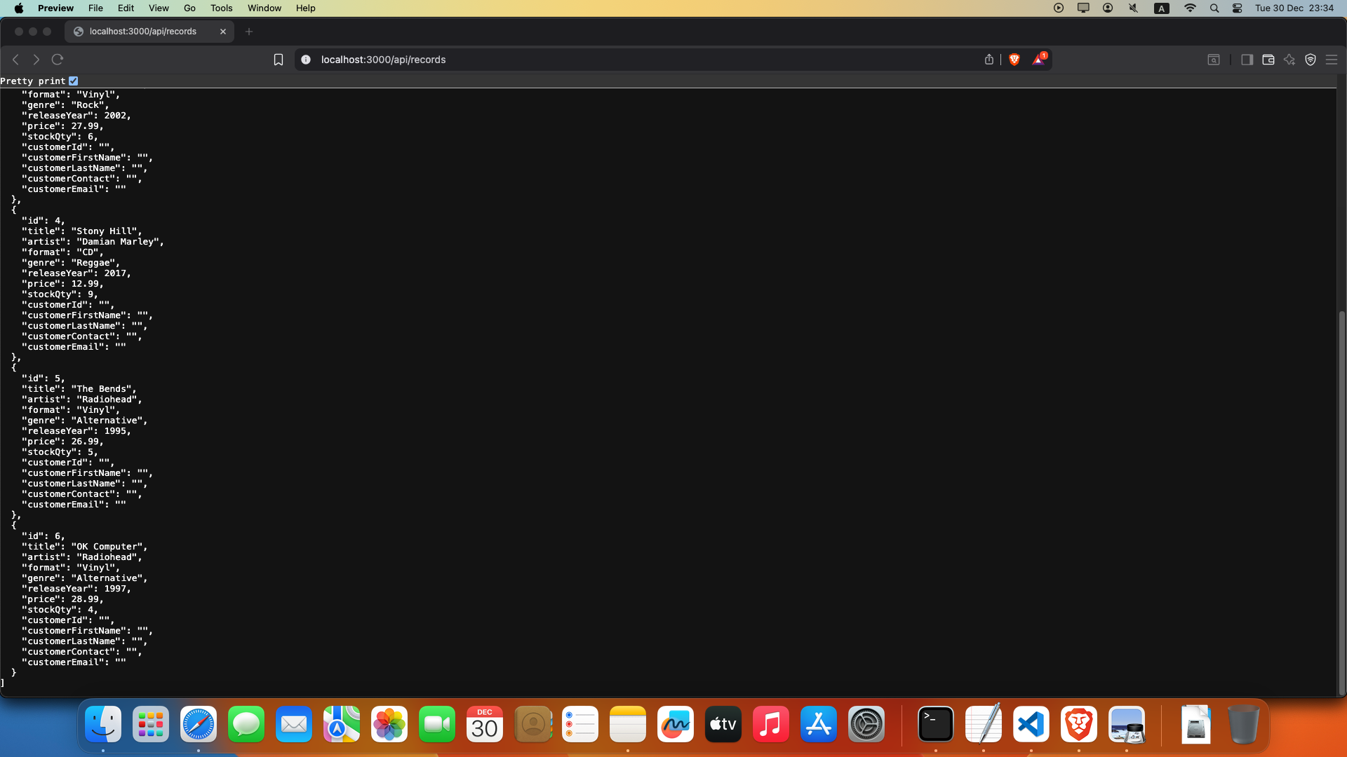

#### Genres

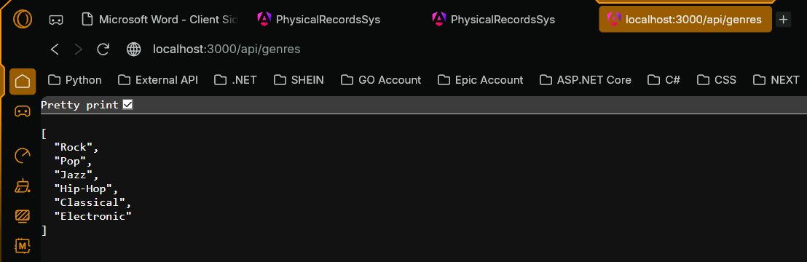

#### Formats

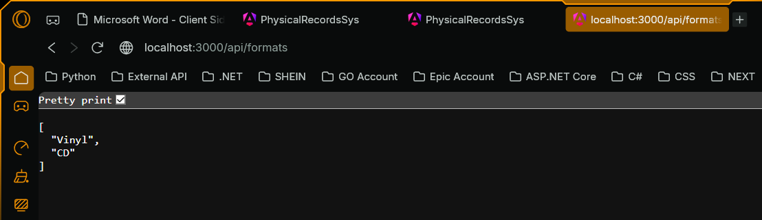

### KU2.3 - Execute the GET request to retrieve all records from within the API documentation using the version of the API that enforces authentication

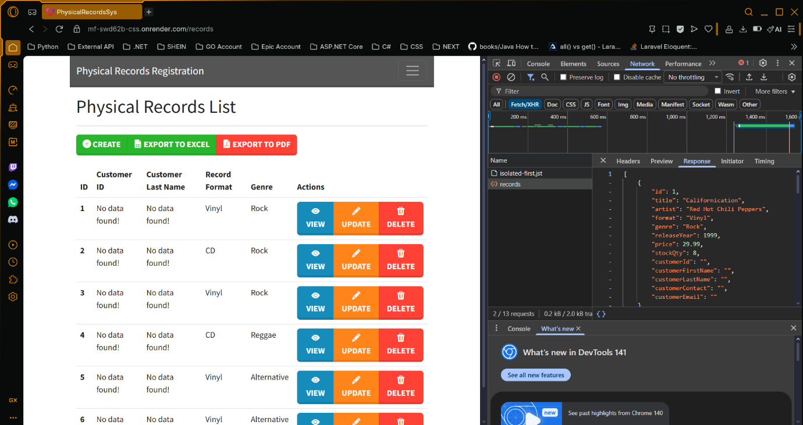

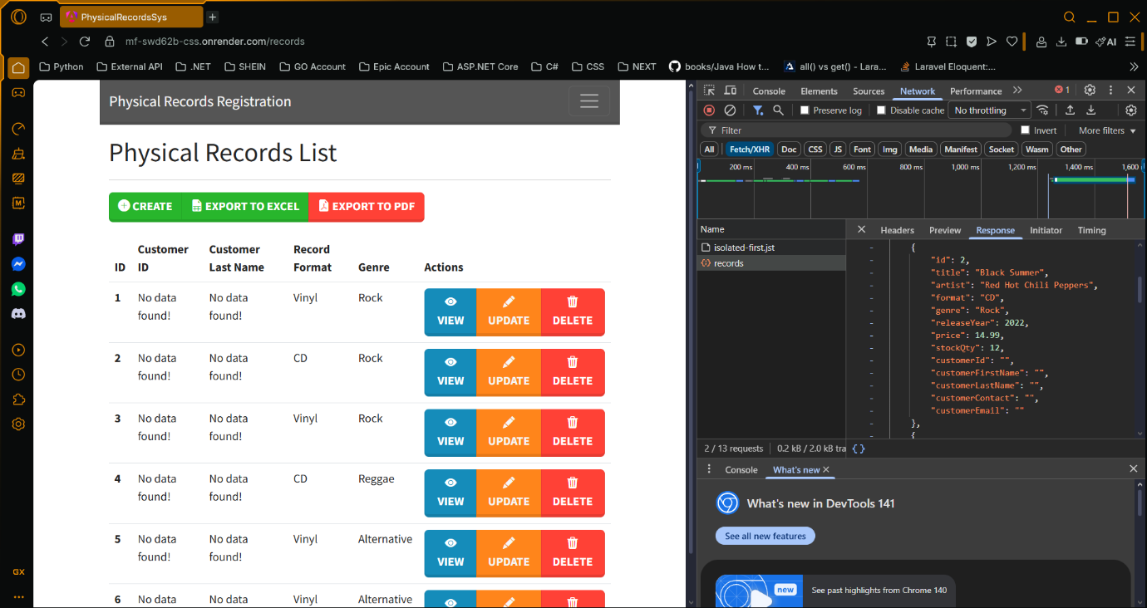

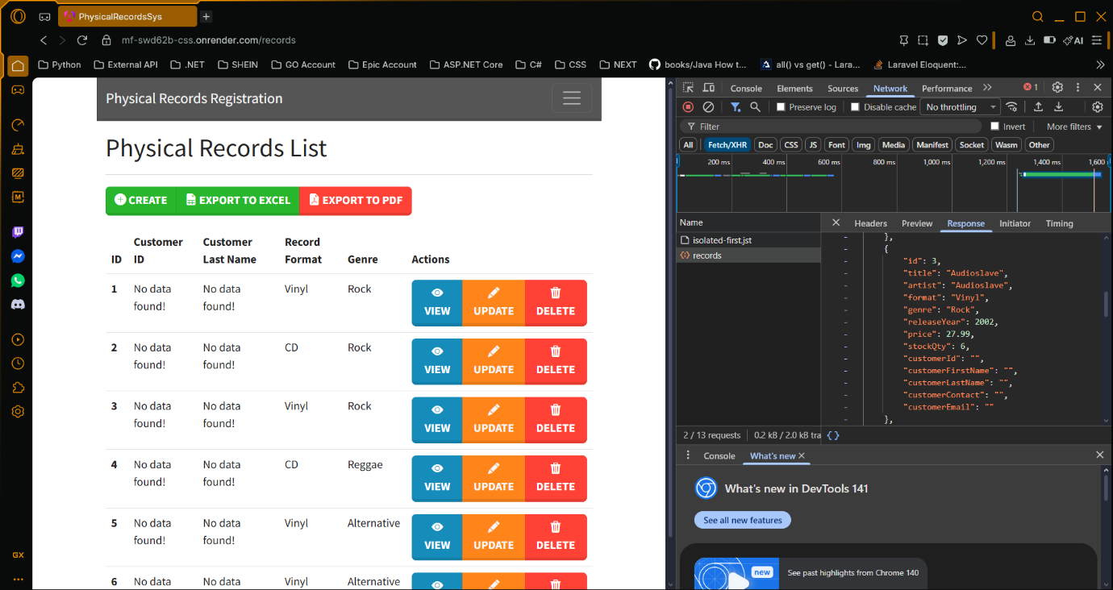

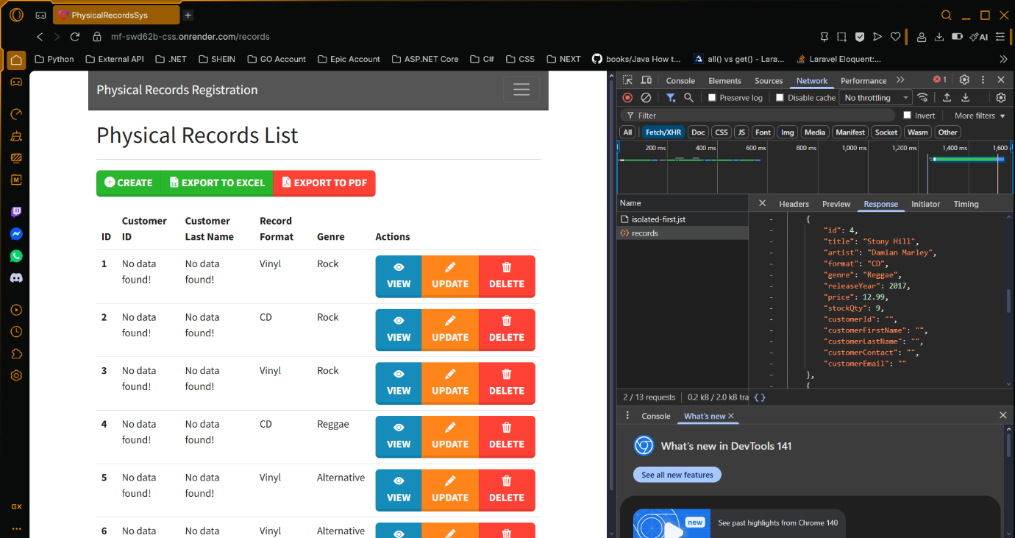

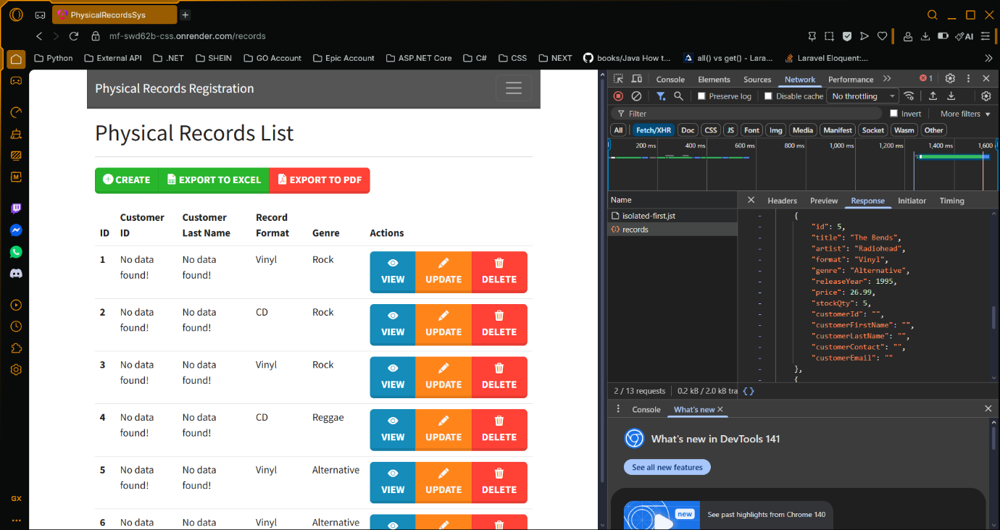

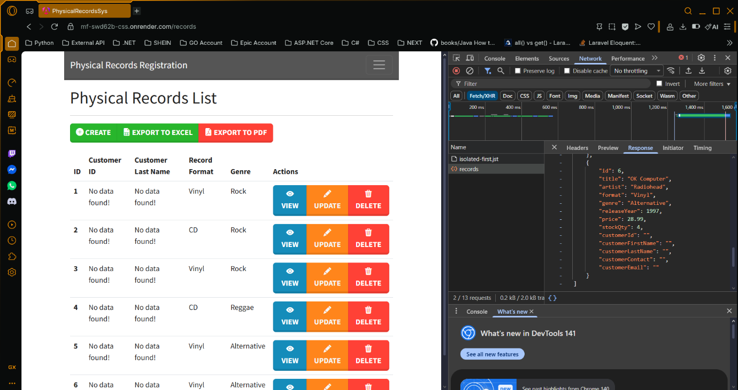

### SE2.2 – Display error message when login fails

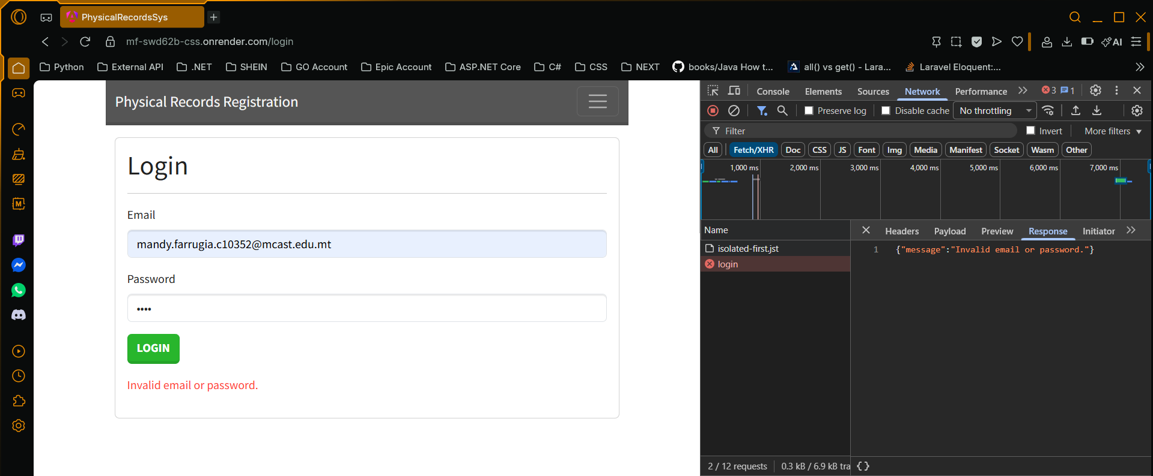

### SE2.2 – Redirect user to list of records if login succeeds

#### Payload

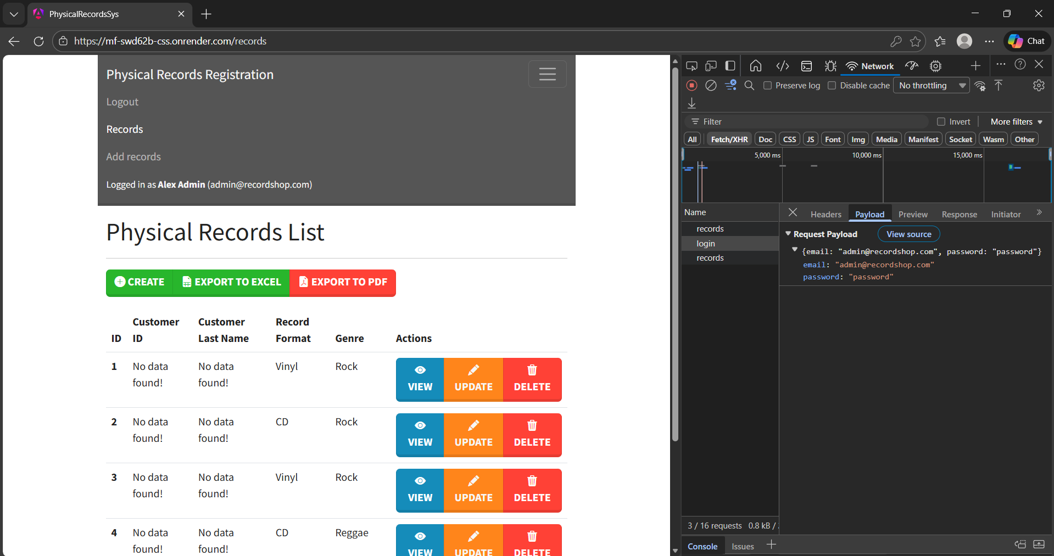

#### Response

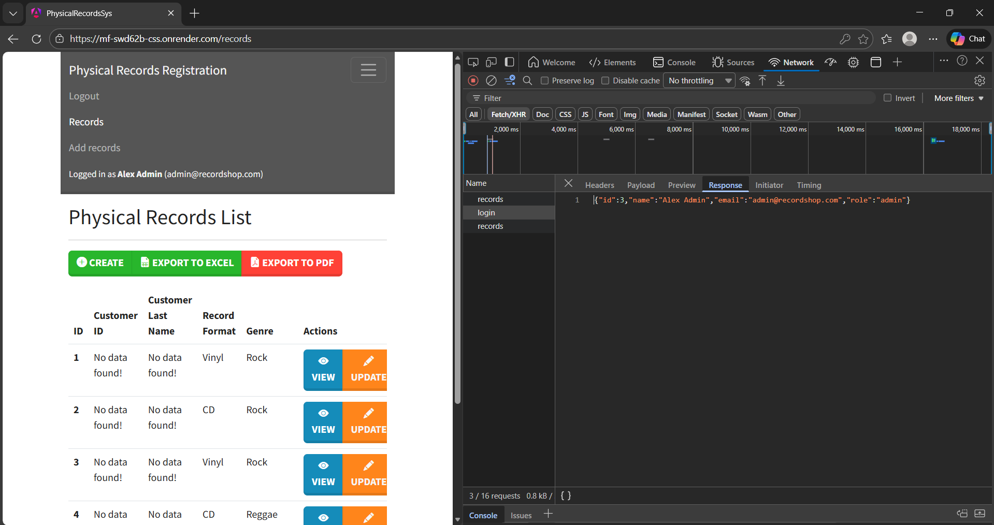

### KU2.4 - Implement the necessary functionality to ensure that a user is only able to go to a particular route if he/she has the appropriate user role

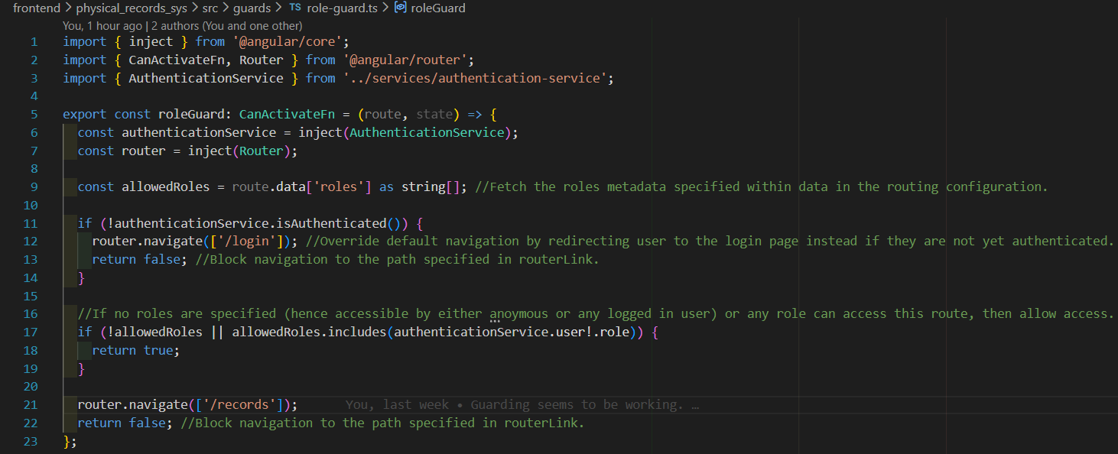

### KU2.4 - Ensure that buttons are only enabled if the user has the required user role associated with the functionality of the button

#### Clerk

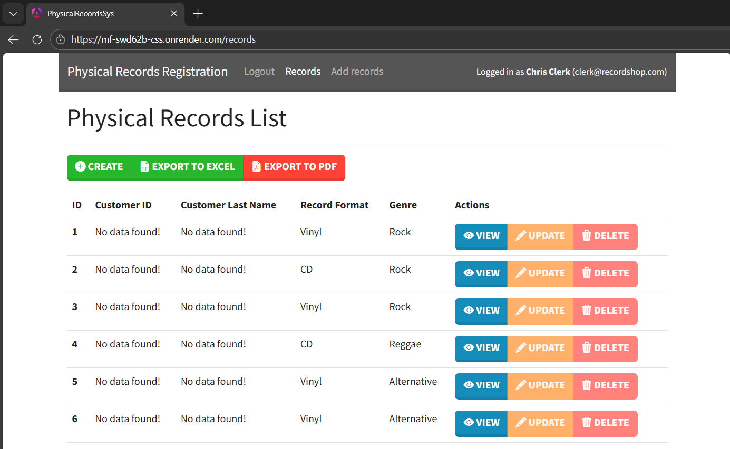

#### Manager

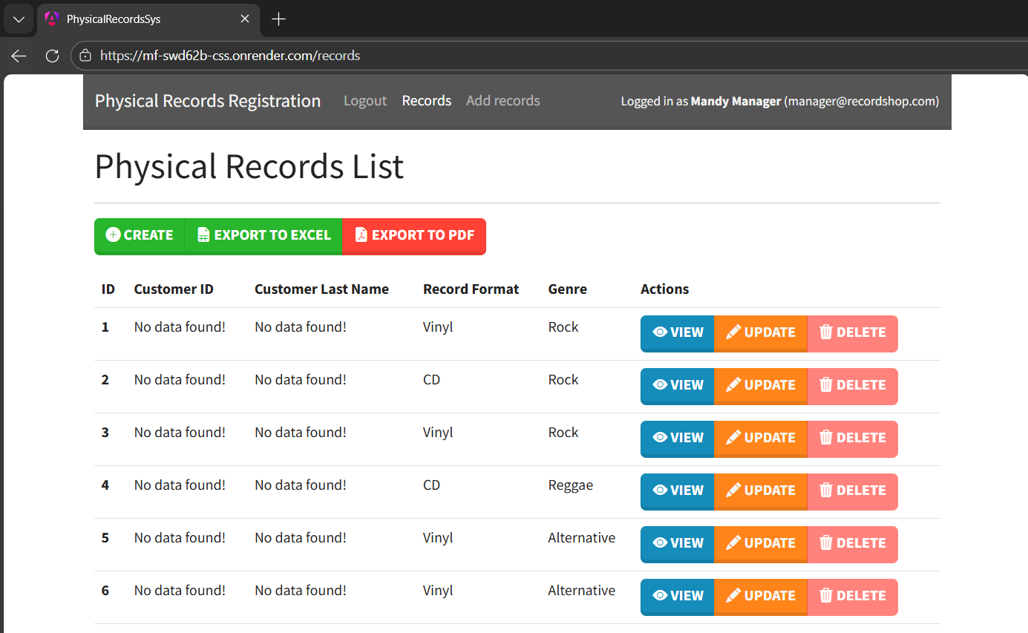

#### Administrator

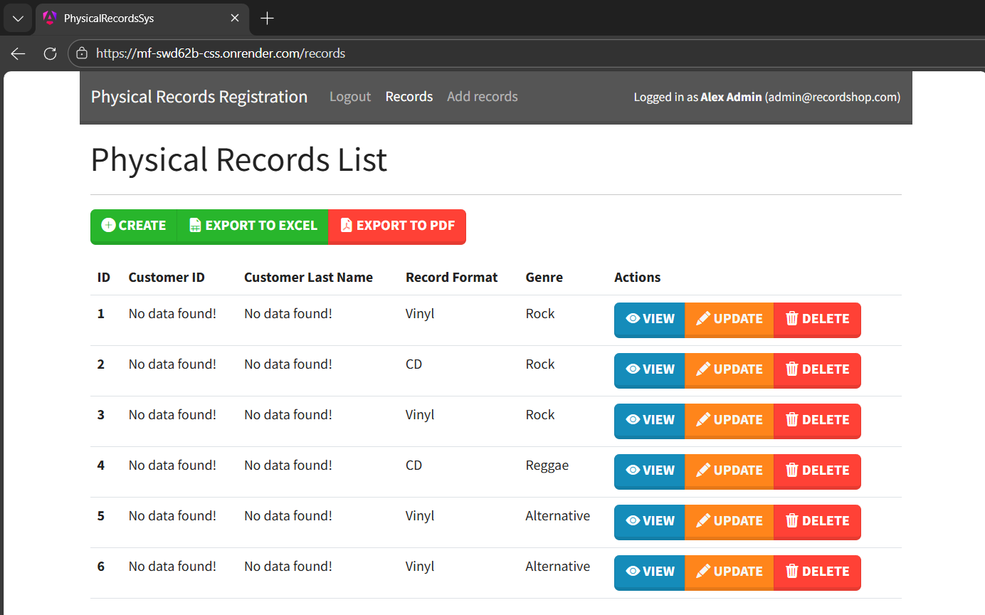

### KU4.1 – Enabling routing

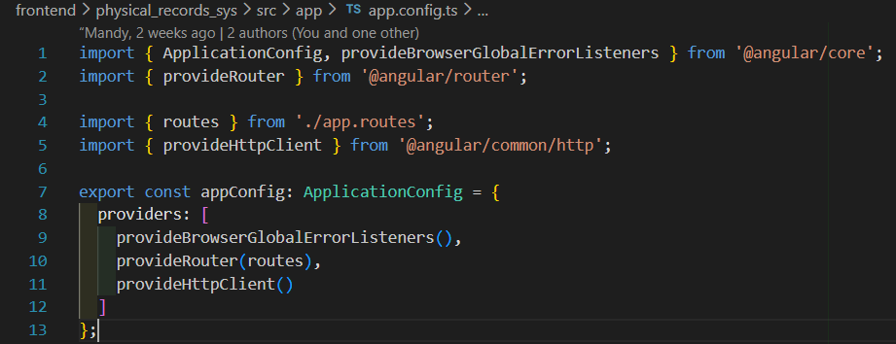

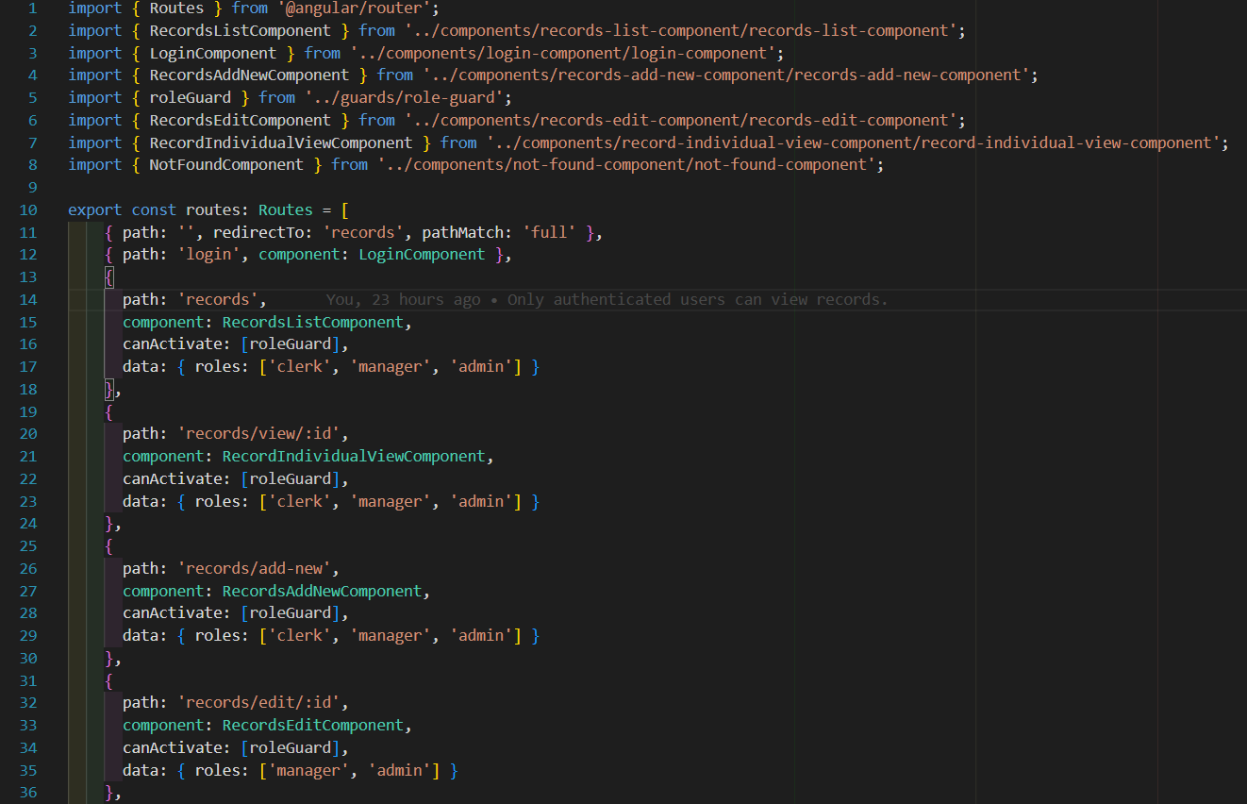

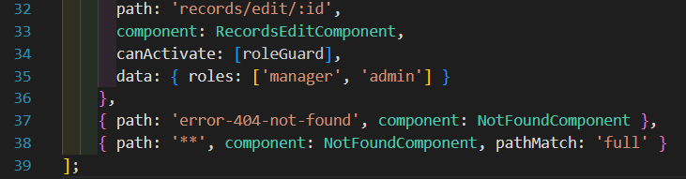

### KU4.1 - Use routing to control which component is rendered in the content area of the main component

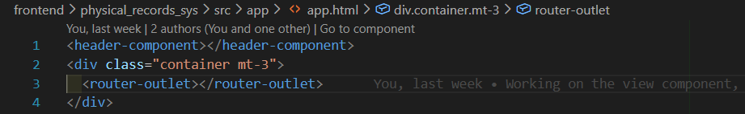

### AA3.2 - Built-in lowercase pipe

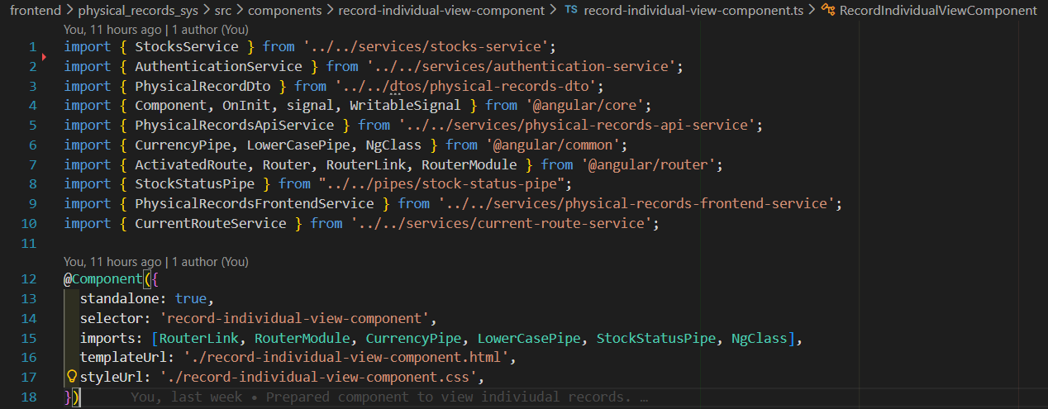

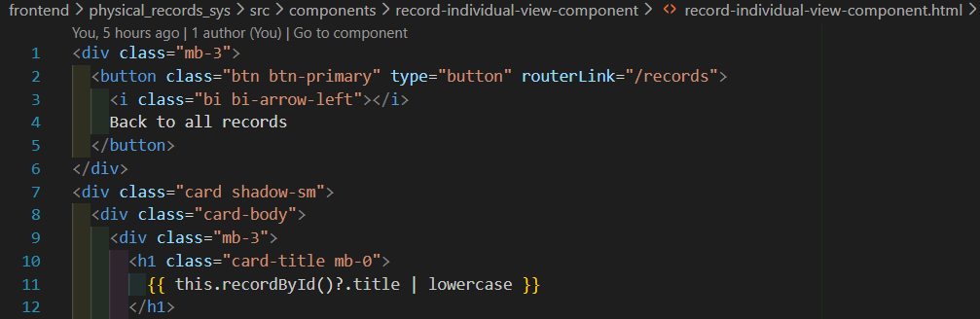

### AA3.2 – Custom pipe implementation

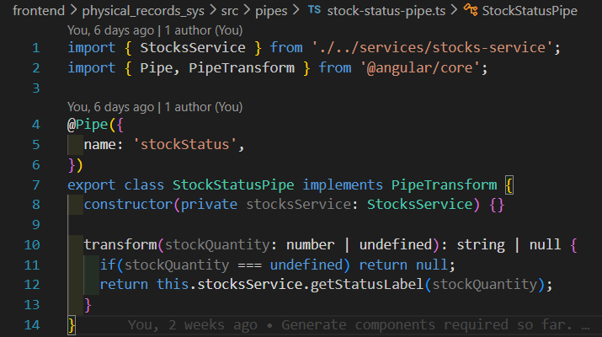

### AA3.2 – Custom pipe usage in user interface

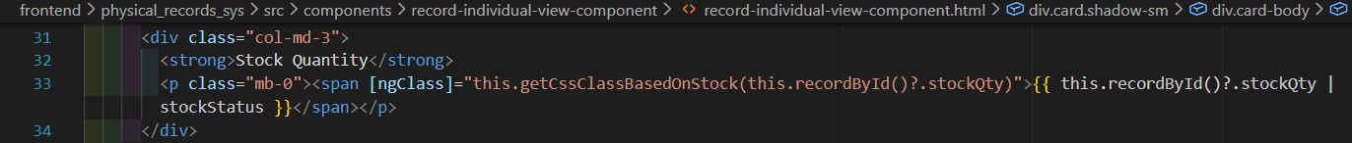

### AA3.4 - Implement a data transfer object to model a registration

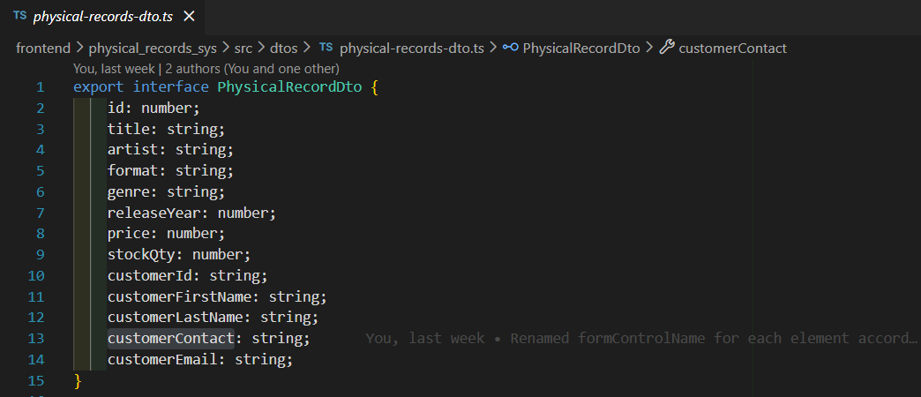

### AA3.4 – Implement the necessary HTTP requests

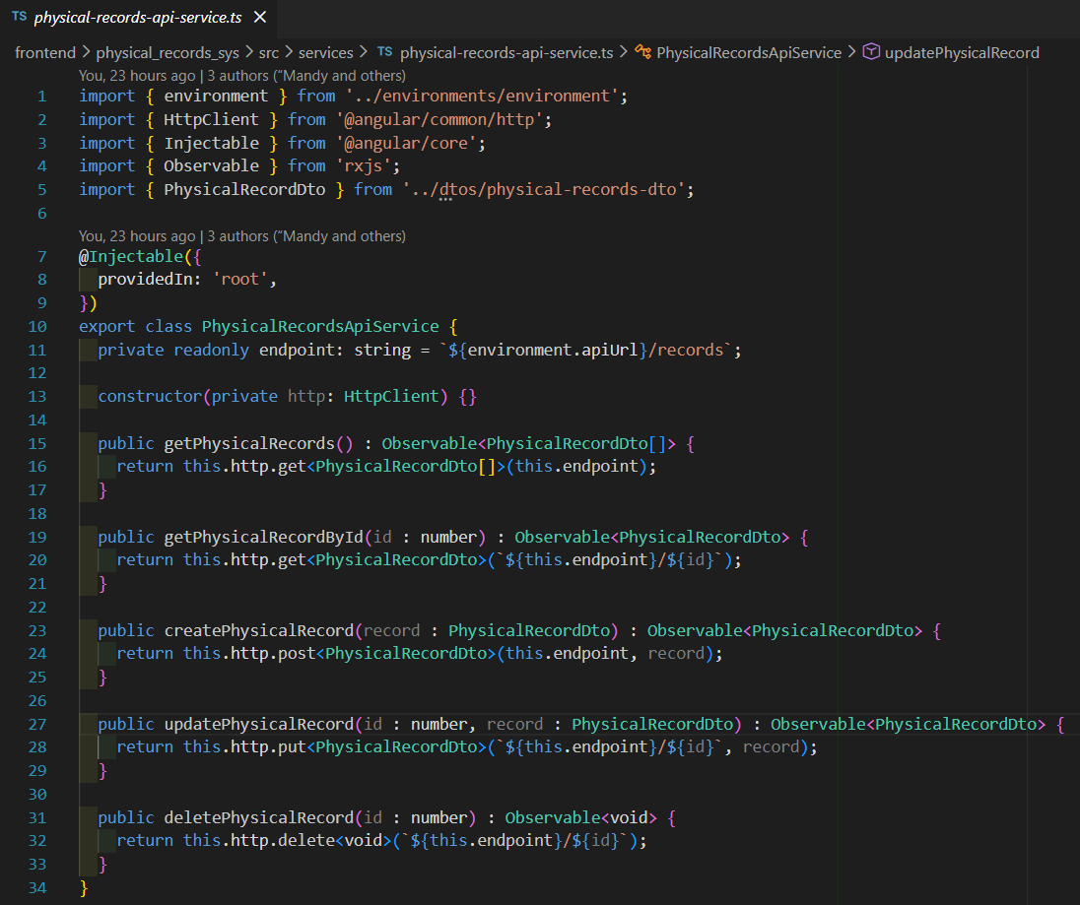

### KU4.3 - Build the app optimized for production

